

Development of an OCR Web Application with Tesseract.js and React.js

Clemente Gonzales

N00193107

Supervisor: Cyril Connolly

Second Reader: Catherine Noonan

Year 3 2020-21

DL836 BSc (Hons) in Creative Computing

Abstract

The purpose of the abstract is to give the reader of the report a concise overview of the project.

Put the following into a single paragraph of not more than half a page.

The aim of this project was to construct a system which …

The rationale for the application. Background.

The purpose of the application is to enable xxx.

The steps involved in the development of the system were ...

Testing was carried out throughout and after implementation. Results from the testing show ...

Further work that could be carried out include xxx, as well as xxx.

Acknowledgements

In this section, you have the opportunity to thank people who have been involved in the project. In particular, you should thank your supervisor for their help.

**The incorporation of material without formal and proper acknowledgement (even with no deliberate intent to cheat) can constitute plagiarism.**

If you have received significant help with a solution from one or more colleagues, you should document this in your submitted work and if you have any doubt as to what level of discussion/collaboration is acceptable, you should consult your lecturer or the Course Director.

**WARNING**: Take care when discarding program listings lest they be copied by someone else, which may well bring you under suspicion. Do not to leave copies of your own files on a hard disk where they can be accessed by other. Be aware that removable media, used to transfer work, may also be removed and/or copied by others if left unattended.

Plagiarism is considered to be an act of fraudulence and an offence against Institute discipline.

Alleged plagiarism will be investigated and dealt with appropriately by the Institute. Please refer to the Institute Handbook for further details of penalties.

**The following is an extract from the B.Sc. in Creative Computing (Hons) course handbook. Please read carefully and sign the declaration below**

*Collusion may be defined as more than one person working on an individual assessment. This would include jointly developed solutions as well as one individual giving a solution to another who then makes some changes and hands it up as their own work.*

|  |
| --- |
| **DECLARATION**:  I am aware of the Institute’s policy on plagiarism and certify that this thesis is my own work.  Student :  Signed |

Failure to complete and submit this form may lead to an investigation into your work.

Table of Contents

1 Introduction (1½ pages) 1

2 Requirements 2

2.1 Introduction 2

2.2 Requirements gathering 2

2.2.1 Similar applications 2

2.2.2 Interviews 2

2.2.3 Survey 2

2.3 Requirements modelling 2

2.3.1 Personas 2

2.3.2 Functional requirements 3

2.3.3 Non-functional requirements 3

2.3.4 Use Case Diagrams 3

2.4 Feasibility 3

2.5 Conclusion 3

3 Design 4

3.1 Introduction 4

3.2 Program Design 4

3.2.1 Technologies 4

3.2.2 Structure of Laravel/Unity/Android (2 pages) 4

3.2.3 Design Patterns 4

3.2.4 Application architecture (1 page) 5

3.2.5 Database design 5

3.2.6 Process design 5

3.3 User interface design 5

3.3.1 Wireframe 5

3.3.2 User Flow Diagram 5

3.3.3 Style guide 5

3.3.4 Storyboard 6

3.3.5 Level Design 6

3.3.6 Environment 6

3.4 Conclusion 6

4 Implementation 7

4.1 Introduction 7

4.2 Implementation Roles 7

4.3 Scrum Methodology 7

4.4 Development environment 8

4.5 Sprint 1 8

4.5.1 Goal 8

4.5.2 Item 1 8

4.5.3 Item 2 8

4.6 Sprint 2 9

4.6.1 Goal 9

4.6.2 Item 1 9

4.6.3 Item 2 9

4.7 Sprint 3 9

4.8 Sprint 4 9

4.9 Sprint 5 9

4.10 Sprint 6 9

4.11 Sprint 7 9

4.12 Conclusion 10

5 Testing 11

5.1 Introduction 11

5.2 Functional Testing 11

5.2.1 Navigation 11

5.2.2 Calculation 12

5.2.3 CRUD 12

5.2.4 Discussion of Functional Testing Results 12

5.3 User Testing 12

5.4 Conclusion 12

6 Project Management 14

6.1 Introduction 14

6.2 Project Phases 14

6.2.1 Proposal 14

6.2.2 Requirements 14

6.2.3 Design 14

6.2.4 Implementation 14

6.2.5 Testing 14

6.3 Team Work 14

6.3.1 Roles 14

6.3.2 Communication 15

6.3.3 Difficulties 15

6.3.4 Resolving Difficulties 15

6.4 SCRUM Methodology 15

6.5 Project Management Tools 15

6.5.1 Trello 15

6.5.2 GitHub 15

6.5.3 Journal 16

6.6 Reflection 16

6.6.1 Your views on the project 16

6.6.2 Completing a large software development project 16

6.6.3 Working in a team 16

6.6.4 Working with a supervisor 16

6.6.5 Technical skills 16

6.6.6 Further competencies and skills 16

6.7 Conclusion 17

7 Business Opportunities 18

8 Conclusion 19

References 20

# Introduction (1½ pages)

Look at Project Guidelines document

Overall aim

Application area

Technologies

Laravel

Vue

Unity

Android

Project management

Team work

Tools

Trello

GitHub

Journal

Requirements

Design

Implementation

Testing

# Requirements

## Introduction

The purpose of the requirements phase is to allow for developers to work out what the application should be able to do. It is important to understand what the users would like the application to do rather than the developer deciding what is required.

The project area that will be looked at will be a progressive web application, with OCR functionality, and an adaptive UI that can allow for mobile compatibility.

Several methods were used to gather information on how the product will be presented. This includes looking at similar applications, conducting interviews, surveys, and questionnaires to find the functional and non-functional requirements that the application will have, as well as gathering opinions on the design of the application.

## Requirements gathering

### Similar applications

The research of similar applications is essential in finding the features that the web-app will be using. When looking at similar applications, the advantages, disadvantages, and descriptions of each website will be examined. The first website that will be looked at is Notion.

#### Notion



Fig XXX displays Notion, which is a productivity application that is designed to boost productivity. The application contains a list of many features that include: the organization of notes into different folders and sub-folders to organize their workspace, to-do lists to display different tasks, a note taking feature, where users can take notes of what they need. This note taking feature also allows for users to customize the font size, colour, background colour, etc. It is also possible to share notes with other users. It is also possible to add widgets to further customize and personalize the look and feel of their workspace.

**Advantages of Notion:**

* The application contains a detailed notes taking feature that allows users to edit notes and customize the look, such as the font size, the background colour, etc.
* The application has a clean look to it and is designed to be user friendly.
* A user can fully customize the folders and the folder structure, allowing for very detailed customization.
* The user can personalize these folders by adding images, icons, and names to them.
* Users can sort, filter, and add tags to the notes and folders that they are using.
* It is possible for a user to share their notes with other people.
* Users can add bullet points, headings, to-do lists, and even tables to their notes.
* Users can also upload images, links, files such as CVs, and widgets to the notes page that they are using.
* Users can search for a note or folder that they are looking for.
* Creating a new page is easy to do and can be immediately accessed at the bottom of the side-nav bar.
* You can import pages to use the structure of other users. This can have new widgets and features such as a clock in the page dashboard.
* When sharing a notion folder, it is possible for other users to comment on the page you are viewing.
* Users can collaborate with each other and create folders where an entire group can use them.
* Users can choose to have a certain folder to be private.
* When deleting a page, you can view the deleted pages in the bin folder.
* A help button is always displayed in the bottom right corner as a “?” sign.
* Notion has a mobile version that functions the exact same as the desktop version.

**Disadvantages of Notion:**

* The user interface is quite intimidating to learn when just starting to use the application, as it is filled with features that can put off new users.
* The images a user chose for their folder picture is only limited to images from Unsplash.com.
* There is no way to directly message other users in the team.

From an examination of this web app, the advantages of notion far outweighs it’s disadvantages and has many features that can prove to be beneficial to the web app that will be worked on. One major benefit of Notion is that it can also be used on a mobile application, and functions the exact same as the desktop version, although slightly slower. Similarly, we can see such benefits in the next application, which is going to be Google Keep.

#### Google Keep



Figure XXX shows the homepage for Google Keep. This is Google’s notes taking application, and to-do list, although focuses more on being a simple to-do list application, rather than a notes taking app. Google Keep also has a mobile version that functions similar to the desktop application. This is an easy and highly effective web app, that is user friendly and very easy to use.

**Advantages of Google Keep:**

* Google keep has an incredibly simple UI, and as a result is very easy to use.
* Users can use Google Keep as a notes taking application, or use it’s to-do lists featues
* Users can organize and sort their notes by using tags to show which folder they belong to
* The web app also uses a side-nav for easy access to all notes
* It is easy to create a new note
* A user can indent their to-do checkbox and have a multi-layered to-do list
* Users can change the background of a note, and can also upload an image of their choice to use a background.
* Users can pin their notes, and functions similarly to a favourites feature. These pinned notes will be immideately brought to the top of the page
* Users can archive, or delete notes
* A users is also able to use a draw feature, where they can draw in the application.
* Users can also add a collaborator and share their notes with other users

**Disadvantages of Google Keep:**

* Google Keep is primarily a to-do list app, and as a result does not have many features for the notes taking section of the application.
* Due to the simplicity of the app, the features are not as detailed as other applications.
* When writing long paragraphs while taking notes, it can be difficult to see them as it is hard to separate into headings and general paragraphs.
* The notes and does not have a way to make the screen larger when reading them.
* You cannot add sub-folders to further organize them.

Despite the disadvantages, Google Keep is an effective web app that acts as an effictive to-do list tool. The indentation of checkboxes to further organize their tasks is incredibly effective and can prove to be a very useful feature when using it. It is primarily a to-do list app, hence why the notes taking features are somewhat lacking, but can prove to still be functional and effective.

The UI of Google Keep is also incredibly easy to use. The simplicity can entice users to use the web app over others that are more complex and confusing to use. A good balance of both notes taking and to-do features are also seen in Evernote, which will be the next application that we will be discussing.

#### Evernote



In figure XXX, evernote is another productivity app that is commonly used. It proves to be a highly effective app to take notes, and contains many useful featues that can allow for easy of use to the users.

**Advantages of Evernote:**

* Contains a draw feature, where users can draw an image, or for hand-written tasks
* Evernote has a to-do list feature, where users can set custom due-dates, set the task to be re-occuring or set the due date to “today” or “tomorrow”.
* A user is able to add shortcuts to allow for quick access to their most important notes.
* A user can also organize them into folders, called “notebooks”.
* It is easy to navigate through the website, and all folders and notes are accessible through the side-nav.
* There is a “recently viewed” tab that can show the recently viewed.
* The notes display the time where it was last edited and viewed.
* A user can share their notes with other members as a shareable link or an invite through email
* Users can add reminders of tasks they have to do that day.
* Users can duplicate a note that they have
* Users can search for something they need in a specific note
* Evernote has a version history, where a user can view each version of their notes

**Disadvantages of Evernote:**

* Again, the notes taking features are not as elaborate and deailed when compared to something like Notion
* Not every feature is availble in the free plan, for example the version history of the notes.

Some of the features listed above are locked by a premium plan, however despite this Evernote proves to be a very good balance of both applications, with complex enough features and an easy to use UI.

### Interviews

Interviews were conducted towards a variety of users to gather information and data on the kind of people who would be using this application. It was also done to see their notes-taking habits and how frequently they would use notes taking applications, and similar tools. The interviews provided great insight into the different user’s habits and provided some interesting features that they would have wished to see in the application.

The first interview conducted was with a 22-year-old student, who is currently studying in their final year of college. This interviewee normally has multiple ways of notes taking, ranging from flashcards to general computer notes, to notes on their phone. The interviewee also finds organizing of notes into folders to be slightly tedious and would prefer if they were more in-depth to allow for further organization.

When asked if the user enjoys making their notes look nice, the user says that they find it beneficial, although they don’t normally spend too much time on it. They would use the basics such as bolding, italics, changing the font size to represent a title, etc.

The interviewee uses a flashcard app known as Anki, and in this app, the interviewee has several folders setup, one for college, one for their own personal development, one for language learning, and one for an archive. The most important folders are set to the top of the list, and in each folder, contains a set of folders including college material, modules, lectures, etc, with each one containing an individual card. A feature that Anki has is to allow for users to add tags to a card and organize those cards into tags to allow for easy sorting of these cards, as all you need to find them is to search.

In this application, the user mentions that it does not have an archive feature built in with the app and mentions that although it is not the most necessary, it would be nice to have that kind of feature in an application for a better ease of use.

When asked what their favourite features were from this application, they mentioned Anki, Notes on IOS, and Trello. In Anki, their loved how there was no paywall, and that it was feature-heavy while remaining free to use, and the gamification of the application, allowing them to constantly return to the application, as there is a daily streak feature that it has.

In the “Notes” app on IOS, they liked the straightforward UI that it has, the autoformat, the checklist, the ability to add checklists, draw, the fact that it automatically arranges by date, and that a user can share notes with other users, and lastly has a global search feature, which allows users to search for a certain thing, and the search feature will look through all the notes to find it.

Finally, the features that the interviewee loves in Trello consists of the checklists, and the priority sorting found in the application.

When asked if an OCR feature would be handy in a notes-taking application, the interviewee replies with “yes, but I would be quite concerned about its ability to read handwritten texts”. They find that it would be handy for other users but note so much themselves as they tend to simply take notes on other devices.

Features they would like to see on a similar application being built would be the gamification of a system like this, spaced repetition, add folders / subfolders, and easily customizable, an archive feature and a global search feature, like the one in the Notes app, and finally a daily notes section.

The second interviewee is a 23-year-old graduate. The interviewee generally didn’t really take notes, even during their time in college, they would often only listen to lectures and rarely take down notes, however when they do, they would always organize it, although it can be mentioned that they would potentially use a notes application in daily life outside of work reasons to bullet journal / consistently journal their tasks.

The interviewee used multiple notes taking applications, however Notion and CollaNote proved to be their personal favourite.

Initially, they originally found Notion to be confusing, with overwhelming UI as there are a lot of features that Notion provides its users and great variety in customization. CollaNote on the other hand was very easy to use and provided many features such as the possibility of exporting as a PDF file, a collection of different templates and designs. CollaNote also contains features such as public rooms, where anyone in the world can write things down, the possibility to insert pictures, draw and even add stickers too.

When asked about their favourite feature, the interviewee quickly brought up CollaNote again. This time discussing a feature that allowed documents to be turned into a PDF, and in this PDF the user is allowed to edit things and highlight things that are written in the PDF too, which the user found to be very helpful.

The next question the interviewee was prompted with was to see if they would make their notes look nice and decorate their notes. The interviewee only uses the simple tools, such as highlights, bold and italics, and bullet points.

The interviewee also thought that an OCR feature would be helpful in an application, as they were very fond of the PDF feature found in CollaNote.

The interviewee is then asked for recommendations on features that they might like to see in a similar application being built, and they replied with a calendar, a section that allows a user to focus on certain tasks for the day, a schedule to make organization easier, that is similar to a timetable, and a to-do list widget or section in the application, to help with the productivity.

### Survey

A questionnaire was carried out to determine the functional and non-functional requirements of the application. It was conducted to find out how users would take notes, and the methods they require to do so. This questionnaire also establishes what features and functionalities that user would like to see in the application, and ways to figure out how to improve upon the flaws found in similar applications already being used.

Microsoft Forms was used to create the questionnaire and was shared on various social media platforms such as discord, Instagram, and Facebook. The survey managed to reach up to 34 participants, with 23 out of the 30 participants consisting of 18 – 24 years old, and 3 participants being 25 – 34 years old. These participants were mostly in college / university, with 64% of them being in a fulltime course.

These results can be seen in the figure below:



In the next question, the user was asked to state how they feel about the following opinions and can be see in the figure below:



From these results, we can gather information that most users answering the questionnaire find that organisation of their notes would be a great benefit towards the application. We can also see that most users would like to see a to-do list feature, personalization and giving them control over how the notes will look when looking through them.

With the user results being collected, it can be agreed upon that these features should be included upon the development of the application.

The next question then asks the user to describe their experiences with notes-taking websites / mobile apps and can be seen in the figure below.



From the results gathered, and reading through the answers, a lot of respondents would often organize notes into different folders to allow for ease of accessibility. Some also found that the UI of certain notes-taking websites were also a little complicated. E.g., a user found notion to be complicated to use, seen in the figures below.



From reading the results of these answers, it should be noted that the app being developed should be easy to use and user friendly, as that was a common flaw found in most of the answers. It should also have an ability to save a user’s notes so that they won’t be lost.

The next question then asks what kinds of features a user would like to see in a notes-taking application, seen in fig XXX.



This question gave a great insight on different features that could be applied to the application. One of which included the ability to customize the look, adjusting different font sizes, bolding and italics, colours, inclusion of images into the file etc. to allow for customization.

Another set of ideas suggested is the ability to link different notes sections to each other, a to-do list feature, a sort filter, bullet points and numbers option, and a clean UI.

The user was then asked whether a “share” feature would be useful when using the application, and as seen in fig XXX, 100% of users agree that it would be a great addition to the application.



Followed up by this question is question 8, where the user is asked why they think it would be a useful feature, to allow for teamwork and co-operation with other users. Potentially friends and classmates. These can be seen in fig XXX.



Question 9 then asks whether a user would take notes on paper and wishes to transfer them to the desktop device, seen in the figure below.



Around 56% of users answered “yes”, showing that potentially developing OCR functionality could be beneficial to the application, as more than half the users could potentially use this functionality.

Question 10 then asks why the user would find it to be a helpful feature, seen in figure XXX. 

From the answers seen, those who answered “yes” state that paper can be easily destroyed, and that it would be more convient to have it saved on a device such as a mobile phone, to have easier access to those notes, as well as for organization purpses. This can be seen in figure XXX.



The respondents who answered “no” to question 9 were also asked for their reasoning behind their answer in question 11. Seen in figure XXX.



Where most users state that they already take notes on their computer, and don’t necessarily need to transfer, however it is also important to note that there are users who simply prefer notes-taking on paper, as they find it easier to retain information that way rather than through desktop.

Question 12 asks if the participant uses any notes taking websites / mobile applications, seen in figure XXX. We can see that there are more users who answered “no”, with 44% answering “yes”.



Question 13 then branches, and first asks the users who answered “yes” to list off the applications that they use, seen in figure XXX.



The users answered mostly with Notion, Microsoft Word and One Note, Google Docs, and Trello. These applications are very commonly used and contain functionality that can provide to be useful when taking notes.

Question 14 asks users if they are satisfied with the functionalities that are in these applications, with most users answering with “yes”. This can be seen in the figure below.



Question 15 asks users what they were dissatisfied with, only retrieving one answer where the users “needs internet to use them”. Seen in the figure XXX.



Question 16 then asks users what they were most satisfied with, and the answers range from cloud accessibility, support for multiple devices, ease of use, and allowing for the notes to look really nice. Some of these responses can be seen in figure XXX.



Question 17 then asks if there are any features that the user wishes to be improved upon, and a common answer was to make the UI simpler to understand and less cluttered. Some also mention to have more functionality such as a built-in timer and music player, the ability to make notes offline and allowing users to attach files, seen in figure XXX.



From the results gathered in the surveys, we have a better understanding of the types of functionalities that the user can be expecting from an application such as this one, and the UI should also be easy to use and easy to understand.

## Requirements modelling

### Personas

Personas are fictional characters that are made to help developers understand what the user’s needs are. These characters also help in identifying the target audience that the developers are aiming for.

The data collected from the survey and interviews help with the creation of these user personas. These personas contain the goals of that character, and their frustrations in what they are currently working on.

The personas created are:

* Sally
* Anya
* Denji

The personas can be seen in more detail in figure XXX, XXX, and XXX



### Functional requirements

The functional requirements contain a list of functions that users should be able to do in the application. The list contains a set of requirements that range from high priority to low priority.

|  |  |  |
| --- | --- | --- |
| # | **Functional Requirements** | **Priority** |
| 1 | Users will be able to sign up or log into the application | High |
| 2 | Users should be able to create a notes folder | High |
| 3 | Users should be able to edit a notes folder | High |
| 4 | Users should be able to delete a notes folder | High |
| 5 | Users should be able view notes folders | High |
| 6 | Users should be able to create a new note | High |
| 7 | Users should be able to update notes | High |
| 8 | Users should be able to view all notes in a specific folder | High |
| 9 | Users should be able to delete notes in a specific folder | High |
| 10 | Users should be able to open notes | High |
| 11 | Users should be able to access OCR functionality | High |
| 12 | Users should be able to upload an image and read using OCR | High |
| 13 | Notes can auto-save | High |
| 14 | Users should be able to save an image to a specific note | Medium |
| 15 | Users should be able to change their email | Medium |
| 16 | Users should be able to change their password | Medium |
| 17 | Users should be able to change their name | Medium |
| 18 | An information icon to show how to use the website should be available | Low |
| 19 | Users should be able to verify password | Low |

### Non-functional requirements

These are requirements which if not met do not stop the application from working, but which mean that the application is not working as well as it should. They are usually based on issues such as:

* Usability
* Performance
* Security

|  |  |  |
| --- | --- | --- |
| **#** | **Non-functionality Requirements** | **Type** |
| 1 | The application should be compatible to mobile screen sizes | Usability |
| 2 | The application should work in multiple browsers | Usability |
| 3 | The application should have information of how to use some parts of the website | Usability |
| 4 | Users should be able to navigate the website easily | Usability |
| 5 | The application should be user friendly and accessible | Usability |
| 6 | Users can access all their notes through a side-nav | Usability |
| 7 | Users will not be able to view another user’s account | Security |
| 8 | User password will require at least 8 characters and contain a number | Security |
| 9 | User password will be encrypted | Security |

### Use Case Diagrams

There are two main users of the web application. These consists of visitors and registered users. The use-case diagram is meant to represent what the users can do once they access the website. The use-case diagram for the application and its potential users can be seen in figure XXX, and fig XXX.



**Visitors:**

* A visitor can create an account.
* A visitor can view the homepage and sign-in / login page.



**Registered Users:**

* A user can log in and log out of the application.
* A user can view all their notes folders.
* A user can create a new notes folder.
* A user can edit a notes folder.
* A user can delete a notes folder.
* A user can open each notes folder.
* A user can view all notes in that folder.
* A user can create a new note.
* A user can edit a note.
* A user can delete a note.
* A user can access the note and edit its contents.
* A user can change the notes font size.
* A user can change the colour of the note font.
* A user can add italics and bold to a note font.
* A user can add a checklist in the note.
* A user can access the OCR feature.
* A user can use the OCR feature to upload an image and read the results from that image.
* A user can discard or save the results to another file.
* A user can add a note to favourites.
* A user can access all notes from the sidebar.
* A user can access notes from their mobile device.
* A user can save their notes through autosave.
* A user can change their email address.
* A user can change their password.
* A user can change their profile picture.

## Feasibility

The feasibility section looks over the different technologies that are to be used together in the development of the application and looks at any technical issues that can arise during development, e.g., compatibility issues.

The application will be developed using the MERN stack, and because of this, the technologies that are to be used are very commonly used together.

The technologies used to develop this application consists of:

* React.js which will provide the frontend of the application.
* Express.js which will be the node.js framework.
* MongoDB which will provide the database.
* Node.js will act as the web server.

These technologies should be very compatible with each other, and technical issues shouldn’t occur when working with this stack because of this.

Due to mobile compatibility being an important feature from the data gathered in the interviews, the application should contain this feature. Mobile compatibility should be accomplishable with the use of React Native to allow for this feature to be implemented. Although due to time factors, it is possible that only a barebones version of this feature will be accomplished, as other more important features are being developed.

Tesseract.js will allow the project to contain OCR functionalities. This library was studied and compared with Easy OCR to see which library can be most effective in a web-application in a previous section of this document. Due to Tesseract.js being a JavaScript library, implementation of this library will be feasible and compatible with the other technologies used in this project.

## Conclusion

In this chapter, the developers are given a better understanding of what features are to be seen in the application, as well as examining user’s needs before starting development and design of the app.

This was done through several methods, including surveys and questionnaires, interviews, and researching similar applications to gather the functional and non-functional features that the application should have.

The survey conducted provided information on what users find useful about notes-taking apps, and to gather general information about a user’s opinion of these apps. This ranged from what they found to be advantageous, what they found to be a disadvantage, etc.

Interviews were then conducted to gather a better insight of a user’s opinions of these applications and gather further information on what they would like to see more of.

The list of functional and non-functional requirements was then listed out, showing the functionalities that the application should contain, ranging from high to low priority requirements, where non-functional requirements showed what extra features the web application can have that will improve the application.

A use-case diagram was also created to show how different users were supposed to interact with the web application, and what they can access as a visitor, and as a user.

# Design

## Introduction

The chapter is to show the development of the design of the application. The design section covers the UI of how the app will look, covering the style guides, typography, wireframes etc, allowing for the developer to view the finish product and where the functionalities will be placed. It also covers the program design, which covers the technologies used and the structure of the code, as well as the database design of the application.

The application that is going to be developed is going to be a web app, that will be developed using the MERN stack. It will act as a text editing application where a user will be able to store notes into folders and take down and save notes. Users will also be able to upload screenshots of notes with text on them and read the text on that note using OCR.

## Program Design

The program design section is essential to make the programming and coding of the application to be better planned and more straightforward, following potential patterns when structuring the code and API.

### Technologies

The technologies that will be used to develop this application will be:

* MongoDB
* Mongoose
* Express.js
* React
* Node.js
* HTML
* CSS
* Axios
* AWS

These technologies were chosen because they generally work well with each other. This functionality helps with the compatibility of the application and can help minimize issues when developing the app.

**React**

React.js is a JavaScript framework that is used to develop frontend web-applications. It is commonly used to quickly develop the frontend of a website and would take much less code than it would when using vanilla JavaScript. (David, 2022)

React was chosen for the reasons listed above, as you can create components that can be reused throughout the website, providing a potentially quick development of the UI of the website.

**MongoDB**

MongoDB will provide the database of the application. The database will be in a JSON-like format and as it is a NoSQL database, the fields and data structures of the database can be changed and provide scalability (What Is MongoDB?, 2022). MongoDB is also easy to work with and is highly compatible with the other technologies that will be used to develop this application, one of which is Axios, which is what will be used to call data from the API.

**Express.js**

Express.js will be covering the backend of the application. The backend API will be written in Express.js, as it is a web-application framework that allows developers to build RESTful API’s (Express - Node.js web application framework, 2017). It is flexible and lightweight allowing for quick development and is compatible with the technologies available in this application.

**Mongoose**

Mongoose is an ODM (Object Data Modelling) library that is used for MongoDB and Node.js. It Is used to manage the relationships between data, provides validation for the schema, and can act as a translator of code for MongoDB. (Karnik, 2018)

It will act as a translator between React.js, Express and the MongoDB, to translate the code and its representation in MongoDB.

**Node.js**

Node is an asynchronous JavaScript runtime engine and is used to develop scalable network apps (Node.js, 2023). It will act as the server of the application.

**AWS**

AWS will allow developers to store the images, with the use of AWS S3 Buckets. This is because MongoDB cannot store images and will need to be uploaded to a different method of storage. In this case, it is S3 buckets.

Another set of technologies that could be used is the Django Framework, although this would have been ideal when developing the OCR application, the time it would have taken to become comfortable with learning Python and the framework would have been too long, and setback progress on the application.

### Structure of React

The structure of React consist of different folders, used for different purposes to keep it organized. This section will be using the folder structure of a previous project and can be seen in fig XXX.



Root Directory:

The root directory consists of all the folders that was used in the previous application. This included the deployment, the build, node modules, public folder, packages, etc.

SRC Directory:

The SRC directory contains the many folders used to develop the application. It is where the code is held, and contains the code and where the different components, assets, pages, etc. are held.

Assets Directory:

The assets directory contains the images that are used throughout the program, and general assets that can also be considered. It also contains the styling files, where the global styles can be stored.

Layouts Folder:

Although not available in Fig XXX. the layouts folder is where it contains layouts for the entire project. For example, it stores headers, footers, nav-bars, etc.

Components Folder:

The components folder is where the components used throughout the entire application is stored. Using a pervious project as an example, figure XXX shows what is inside the components folder.



As seen in the fig XXX, the different functionalities are stored in this folder, and contains components such as cards, buttons, and forms. These components are globally available throughout the entire application and can be called and used in the different pages available.

Config Folder:

The config folder contains a set of configuration files, that can be used to store environment variables. These variables are accessed throughout the entire application.

Pages Folder:



Figure XXX. shows the pages folder, which contains all the pages that the application has. Within this folder is a sub-folder that organizes the characters page towards their components. These pages normally contain components grouped into one.

App.js:

App.js is used to display the application. It contains all the folders, routes, pages, and components within the application.

Index.js:

Index.js displays the app.js file.

Routes Folder:

This folder contains the many routes of the application, ranging from private and protected routes, and all other types. It can be seen in the figure below.



The backend of the application also contains the “controller”, the “data”, and the “models” folder, which is used to store the schema, controllers and data of the application.



Controllers Folder:

The Controllers folder holds the CRUD functionalities of a specific object in the application, e.g., CRUD of a specific character in the case of the previous application.

Models Folder:

The Models folder holds the schema of the application, and how this object will be stored in the database, containing the attributes of e.g., a character for example.

Utils Folder:

Finally, the Utils folder contains the utilities used throughout the application. E.g., the database

### Model View Controller Design Pattern

The Model-View-Controller is a design pattern that is used to split an application into 3 different components: the Model, the View, the Controller. These components handle specific requests throughout the application. It is efficient, and scalable, and is an industry standard.

* The Controller receives the requests from the user and sends it to the model.
* The Model responds to actions that are requested and returns it back to the controller. Once this is done the Controller sends it to the View.
* The View then responds with the data back to the user.

The diagram seen in Fig XXX displays the Model-View-Controller design pattern.



### Application architecture

A web application architecture is a guide on how an application’s software are used together, and how that application reacts with each other. This can allow for scalability and reliability as they display the interactions are between things like middleware, databases, and the frontend (Ferguson, 2021).

In this application, the application is using the MERN stack, which consists of MongoDB, Express.js, React.js and Node.js. In this stack, React acts as the frontend of the application, it is used to quickly build UI and allow for the components that the website will be using. MongoDB will then act as the database for the application, taking in the requests sent by the user and sending back a response to the user with the requested data. It is used with components consisting of JSON and uses JavaScript. Express and Node.js will then act as the backend and server of the application, taking in API calls and requests and placing the data requested to the webpage.

The diagram below (figure XXX) displays the application architecture for this project, displaying the frontend, the server, and the database, as well as showing the requests and responses that is returned from the database.



### Database design

The figure below (figure XXX) shows the embedded data models. These data models are seen in the JSON file in MongoDB and are shown to represent how it looks in the database. These embedded data models are required to store a set of related data in a singular database record.



ERD’s (Entity relationship diagrams) were also created to better display the relationships between each item in a diagram. The ERD of the project is displayed in the next image (figure XXX) and can be better seen in Figma: <https://www.figma.com/file/8wushDYxUM3YNyoGlC2RUW/Final-Project?node-id=0%3A1&t=vzfT2FTUSNURtNsh-1>



### API design

|  |  |  |
| --- | --- | --- |
| **REST Method** | **Endpoint** | **Description** |
| **GET** | /user/ :id | Get User |
| **POST** | /register | Sign Up |
| **POST** | /login | Log In |
| **PUT** | /edit/user/ :id | Update user details |
|  |  |  |
| **POST** | /folder | Create Folder |
| **GET** | /folders | Get All Folders |
| **GET** | /folder / :id | Get Single Folder |
| **PUT** | /edit/folder/ :id | Update user details |
| **DELETE** | /folder/ :id | Delete Single Folder |
|  |  |  |
| **POST** | /note | Create Note |
| **GET** | /notes | Get All Notes |
| **GET** | /note/ :id | Get Single Note |
| **PUT** | /edit/note/ :id | Update note details |
| **DELETE** | /note/ :id | Delete Single Note |
|  |  |  |
| **POST** | /ocr_img | Create OCR Image |
| **GET** | / ocr_img | Get All OCR Images |
| **GET** | / ocr_img/ :id | Get Single OCR Image |
| **DELETE** | / ocr_img /:id | Delete Single OCR Image |
|  |  |  |
| **POST** | /checklist | Create Checklist |
| **GET** | / checklist | Get All Checklist |
| **GET** | / checklist / :id | Get Single Checklist |
| **PUT** | /edit/ checklist / :id | Update Checklist details |
| **DELETE** | / checklist / :id | Delete Single Checklist |

### Process design

To show different sequences that the user might be going through while using the application, a sequence diagram was created to display the process of what can be done while using the application. The sequence diagram can be seen in figure XXX.



## User interface design

This section discusses the design of the user interface. This is done through a set of steps that look at the different requirements that were initially found in the previous section and implemented with the functionalities and design in mind.

The app will first look at paper prototypes, wireframes, user-flow diagrams, and style guides.

### Wireframe

 A wireframe is used to display the content and functionality of the layout of a page. These wireframes usually do not consist of colour, or typography or much detail to begin with. We start the development of the wireframes by initially creating a set of paper-prototypes that are used to develop ideas on where to put different pieces of functionality and how to use the system.



Paper prototypes are generally done before building the wireframe, and are seen in the figure above (fig XXX)

One the development of these paper prototypes are complete, having a slightly more developed version (without detail) is then created. The lo-fidelity (lo-fi) wireframes are then made with the use of paper-prototypes as a guideline. The lo-fi wireframes show a better look of how the application will look, and prove a closer look into how the final application will look.

The wireframes are provided in figure XXX below, and was designed in a prototyping tool known as “Figma”



### User Flow Diagram

The user flow diagram shows how users will navigate from one page to another within the application. It can be seen in figure XXX down below.



The full diagram can be seen in: <https://www.figma.com/file/8wushDYxUM3YNyoGlC2RUW/Final-Project?node-id=0%3A1&t=Cc2mS5tSz8jgz3fE-1>

### Style guide

The style guide shows the colours, typography, layout, form elements, buttons, tabs, and cards for how the website is going to look. Style guides are often used to keep the website looking consistent. It also covers the grids and spacing of the application and how they are used throughout the website. The full style guide can be seen below in figure XXX.



**Typography:**

The font that will be used for heading will be Croissant One in several different sizes for the headings to indicate importance. These headers will not be used often and will be reserved for headings and areas of importance. The reason behind using this font is because it is easy to read and suits the look and feel of the website. The paragraphs will consist of Roboto Light as it contrasts well with the heading font and is also clear and easy to read, making it a great choice for the body of the website. A screenshot of the typography can be seen in figure XXX.



**Colour**:

Colour will be used sparingly throughout the website. It will be used to highlight important objects that are seen throughout the website, such as buttons. The colour pallet will remain simple, as the main use of colour throughout the application will be from images. Figure XXX shows the colour pallet of the application.



**Spacing:**

Spacing is used to keep the application consistent with the size and how far each element is away from each other. The consistency of the spacing is essential to allow for a more professional looking application. The spacing is seen in figure XXX.



**Buttons:**

Buttons are used throughout the entire website. The different buttons are for different occasions, for example “return to homepage” will only be used in the sign up and log in form. These buttons can be seen in the figure XXX.



**Forms**:

The form will consist of the text area and the name, it will also contain the buttons that are needed. This can be the “sign up” button, the “confirm” button and the “return to homepage” button.



**Tabs:**Tabs are used to display where the user is in the website. It is used for easy navigation and is accessible through the side-nav. The tabs are kept simple and clean to allow for as little visual clutter as possible when navigating the website. Figure XXX shows the tabs when navigating the website.



**Cards:**

Cards are used to help distinguish the different notes that the user creates. The cards available will contain an image and a name of the note to allows users to differentiate it from others. It remains simple to prevent visual clutter, with a drop shadow to highlight card itself. The second card shows when the user needs to save a note after using the OCR functionality. The two cards can be seen in figure XXX.



**Iconography:**

**[INSERT ICONOGRAPHY IMAGES HERE]**

## Conclusion

Write a couple of paragraphs summing up the chapter. Explain what area your project is about. Describe what the chapter has discussed.

# Implementation

## Introduction

The implementation chapter discusses how the application was developed, as well as the technologies used to build it. This chapter will be discussing the different technologies used within the project, and the sprints that occurred throughout the project, and the items that were completed within each sprint.

## Technologies

The technologies that were used to develop the application are seen as follows:

* **React.js**

React is a JavaScript framework that is primarily used to develop the front-end of an application. React is component-based and can be used to quickly develop an effective and intuitive, web-based UI (David, 2022). The reason for choosing React.js was primarily for its components, vast number of libraries and resources, and it’s React Native feature, to allow for mobile-compatibility, and its fast development.

* **Express.js**

Express.js is a fast, and unopinionated web framework for Node.js that is used to build RESTful APIs and will provide the backend for the application. (Express - Node.js web application framework, 2017)

* **MongoDB**

MongoDB will act as the database for the application. It is a very flexible database and scales very well as the application develops.

* **Mongoose**

Mongoose is an Object Data Modelling (ODM) and is used for MongoDB and Node.js. It can handle the relationships between the data and can translate objects within code and how it is represented in the database, as well as provide schema validation. (Introduction to Mongoose for MongoDB, 2018)

* **AWS S3 Bucket**

AWS S3 is an Amazon object storage service that can retrieve and store data. It will be used in the application to store images. (Getting Started – Amazon Simple Storage Service (S3) – AWS, 2023)

* **Socket.io**

Socket.io is a library that allows for cross communication between a client and server, and is used in our text editor to share documents with other users. (Introduction | Socket.IO, 2023)

* **Tesseract.js**

Tesseract.js is a JavaScript library port of the Tesseract OCR engine. The port will allow developers to use OCR functionality in a web-based application. The library is used to provide the OCR functionalities seen in the application. (Tesseract.js | Pure Javascript OCR for 100 Languages!, 2023)

* **Quill**

Quill.js is a powerful text editor library, that will be used to provide for the notes-taking feature that the application will have. It is powerful, easy to use and customizable (Quill - Your powerful rich text editor, 2023). The reason behind using Quill is because of the Delta feature, which allows developers to store the position and style of that specific document in a backend.

* **Figma**

Figma is a free online web service that is used for designing UX / UI applications. Figma was used to design the wireframes, and UI of the project, and to create the design systems of the application.

The application that will be developed for this project is a note taking application that contains OCR functionalities. The user will be able to create new documents, sort their documents into folders and use OCR functionalities alongside the notes taking features to help users take notes on different mediums and transfer it to the application.

## Implementation Roles

The project consisted of a single developer, and a project supervisor and secondary reader. The project will be developed by Clemente, including all the design, functionalities, and testing that is seen throughout the project, while being supervised by Cyril Connolly. Weekly meetings were held, where updates for the project progress and criticisms were exchanged between the student and supervisor and were consistent during the development process.

## Scrum Methodology

The requirements for the application were listed in a product backlog. Each item on the product backlog was broken down into a series of tasks which formed a sprint.

Scrum Methodology was used for the implementation of this project. The Scrum methodology follows the Agile Development methodology, and divides the project into smaller, manageable goals that are achievable throughout development. These goals are generally accomplished within one to two weeks, called sprints, depending on the plan that the developers have set out. (What Is Scrum Methodology? & Scrum Project Management, 2022)

The project is divided into different roles, which consists of:

* Scrum Master – The Scrum Master is to guide the developers and manage the project. They will oversee the project, keeping the Scrum up to date and will provide training and mentoring in case a team needs it (What Is Scrum Methodology? & Scrum Project Management, 2022)
* Software development team – The team that will be developing the project and following the Scrum goals.
* The product owner – Will be the clients that will use the software that is being developed.

In this project, Cyril will provide the role of the Scrum Master, while Clemente will be the software development team that will accomplish the goals set out to him.

Each sprint in the project will be completed every two weeks, and in total consisting of 7 sprints, and a set of goals will be accomplished within those sprints. The figure below shows how the scrum methodology was used:



(What Is Scrum Methodology? & Scrum Project Management, 2022)

The requirements for the application were broken into a product backlog, and each item on the product backlog was broken down to smaller functionalities, which created the sprints. The product backlog can be seen in the figure below:



These sprints were accomplished over the course of two weeks, and encouraged developers to be productive to keep up to date with their work.

## Development environment

### Visual Studio Code

Visual Studio Code is a fast code editor that supports developers by syntax highlighting, bracket-matching, auto indentation and many more. It allows developers to inspect and debug their code and add many other plugins that is created by the community. (Visual Studio Code, 2021)

The reason Visual Studio Code is being used is because it runs well with web development and JavaScript and can highly different errors that can occur during the development process. It is fast, easy to use and highly customizable to run with different plugins.

Visual Studio Code is where most of the code will be written. It is compatible with React, JavaScript, Mongo, Mongoose and works very well when also using Node to install the packages that will be used to develop the application.

### GitHub and Git

GitHub provides a method of version control. It will be used to create the many commits that will be created and tracks the different changes that a developer makes within those commits. It can also provide for different branches and merging. (What Is GitHub? A Beginner's Introduction to GitHub, 2022)

The version control system was essential during development to help save progress or revert to a previous version in case the current version is too broken to salvage.

The way these versions are uploaded to GitHub is using Git commands, which allows for the different features and commits to be saved.

## Sprint 1 - Research and Requirements

### Goals

The goal of Sprint 1 is to research project ideas, view similar applications, and conduct surveys and interviews to gather information on a user’s needs.

* **Item 1:** Research the ideas for project in a similar area.
* **Item 2:** Create a simple OCR prototype in React. **[CHANGE TO RESEARCHING OCR TECHNOLOGIES IN REACT]**
* **Item 3:** Gather User Requirements
* **Item 4:** Create User Personas
* **Item 5:** List Functional and Non-Functional Requirements of application
* **Item 6:** Create Use-Case Diagrams

### Item 1 – Researching Project Ideas

The goal of this item was to perform research for the project area, and find out what will be built towards the end of the application. Due to the nature of OCR being heavily committed with writing, developing a notes-taking application with OCR functionality was decided early into the project. The idea of the project was to allow users to take notes on pen and paper and transfer those notes to a desktop application to give them flexibility in where they can store their notes.

### Item 2 – Prototyping

Technologies were then researched to see if this application was feasible to develop. As it turns out, there are available libraries for React.js to that will allow developers to build an OCR application. One of these being Tesseract.js, a port of Tesseract OCR to a react library, usable within JavaScript.

A prototype was then developed in React.js to see if it is possible to add this feature.

Prototypes for the notes-taking side of the application was also developed during this time. A library called “Quill.js” was used to develop the notes-taking part of the application, as it is a very powerful notes taking library with the ability to store the properties of what is in the documents.

Tutorials were used and altered for both the OCR prototype and the Notes taking prototype, and can be seen in: XXX

**[WHERE SHOULD TUTORIALS BE CREDITED?]**

### Item 3 – Gather User Requirements

Gathering the user requirements was to find the different functionalities and features that a user would be able to use within the application. The requirement gathering process was done in three ways to maximize the usable functionalities within the application.

These steps consisted of:

* Researching similar applications
* Surveys
* Interviews

#### Item 3.1 – Researching Similar Applications

Similar applications were looked and examined to find the advantages and disadvantages of that specific application. High quality applications were looked at to ensure that the functionalities of the program that is being built will contain the essential features of a notes taking application.

The applications that were researched were:

* Notion
* Evernote
* Google Keep
* **[OCR APPLICATION]**

The advantages and disadvantages of these applications can be found in Research Section of this report.

#### Item 3.2 – Surveys

Surveys were conducted to gather mass data on the application. The surveys were sent to gather data on whether the common person uses notes taking applications, what they like about these applications, and the different features that they would like to see on an application like this.

These surveys returned a variety of responses and helped further determine the functionalities that the application will possess.

The results can be seen in the research section of the report.

#### Item 3.3 – Interviews

Users were also interviewed to find what features suit them, what they would like to see and how they interact with these kinds of notes taking applications.

In these interviews, the users were asked what their favourite features were from notes taking application that they have previously used, and the results were listed in the research section of the report.

### Item 4 – Creating User Personas

A set of user personas were created to showcase the potential users who will be using the application, and to display their needs and wants that the application should provide. These personas can be seen in figure XXX, and is shown in greater detail in the research section



### Item 5 – List of Functional and Non-Functional Requirements of the application

Functional and Non-Functional requirements were then listed. These requirements were gathered from the needs that has been provided from the information that was gathered from the surveys, interviews, and personas. The requirements were listed from high to low priority to show the developers what to prioritise during the development of the application. The list can be seen in the research section of the report.

### Item 6 – Creating Use-Case diagrams.

A use-case diagram was then created to showcase what certain users can do. These diagrams show the registered and un-registered users and what the application allows them to do.

### Conclusion of Sprint 1

The overall goals of this sprint were accomplished and gave a clear end-product on what should be built towards the end of the project, showing the functionalities and needs that should be implemented towards the end of the project.

## Sprint 2 – Design

### Goal

The goal of Sprint 2 was the design the different parts of the application. These included both the Program Design, and the User Interface Design, showcasing how the project will be developed in its design systems, as well as the look of the application.

* **Item 1:** Research the Technologies
* **Item 2:** Database Design
* **Item 3:** Process Design
* **Item 4:** Wireframes
* **Item 5:** User Flow Diagram
* **Item 6:** Style Guide

### Item 1 – Researching the Technologies.

This item consists of performing research on the technologies that will be used in the application, the design patterns that will be used and the architecture of the overall application.

* Technologies and Structure

The technologies that will be used for this application was displayed in this section, showcasing the stack that will be used and explaining the reasoning behind using them.

The structure of how React.js is used was also discussed, showing the different folder structures, and explaining the reasoning behind that structure.

The Model View Controller (M.V.C) design pattern was also discussed in this section, showing how the stack uses M.V.C and a diagram to compliment it too.

Application Architecture was also in this section, it is to show the connections between the technologies and how they all worked together to create the finished product.

These can all be seen in further detail in the design section of the application.

### Item 2 – Database Design

The database design section then showcases the structure of the database. Diagrams were created to show the relationships between data, and how they will connect with each other. These diagrams include a Database Record and Entity Relationship Diagram and can be seen in the figure below (figure XXX), and in greater detail in the Design section of the document.



### Item 3 – Process Design

The API and Process Design were created in item 3.

The API design shows how the calls should look in the backend of the application, and what calls a specific entity should be able to perform.

The process design then shows a sequence diagram that show the process of what is being performed.

These diagrams can be seen in the design section of the report.

### Item 4 – User Interface Design

Item 4 then shows the creation of the User Interface Design of the application. This is done through a series of steps that allows for a final design to be created, which includes:

* Paper Prototypes and Wireframes
* User Flow Diagram
* Style Guides

#### Item 4.1 – Paper Prototypes and Wireframes

Paper prototypes were produced to quickly lay down ideas for a potential UI design. This was done to allow for mistakes and fast creation, and to give ideas on how the webpage will look before wireframes are produced.

Once a paper prototype was completed, a wireframe is then created. The design of the wireframe is based on the design of the paper prototype, however the wireframe is built in a design tool. In this case, the wireframe was built using Figma.

These paper prototypes and wireframes can be seen in the figure below (Figure XXX) and can be seen in greater details in the Figma board, or the design section.



#### Item 4.2 – User Flow Diagram

A user-flow diagram was then created to show how a user will interact with the website, and the pages that they are to be led to, after clicking a specific button, or nav component. This was done to show how they will interact with the design and for navigation purposes. The user-flow diagram can be seen in figure XXX



#### Item 4.3 – Style Guide and Finished Design

Finally, a style guide and the finished design was created. The style guide was built to give the UI of the application a consistent look, and to chose the colour scheme, iconography, font and font sizes, etc.

With the style guide completed, the finished design was then constructed, and built with the use of the style guide and the wireframe.

The finished design and style guide can be seen in figure XXX.



## Sprint 3 – Implementation 1

### Goal

The goal of sprint 3 was to begin the implementation of the application. During this sprint, prototypes were further developed separately to see if the different parts of the application can work together. The items that were developed during this phase of the project were:

* **Item 1:** OCR Functionality prototype.
* **Item 2:** Notes taking prototype.
* **Item 3:** User profile.

### Item 1 – OCR Functionality Prototype

A prototype for OCR functionality was developed in React. The tutorial used to develop this prototype was found on YouTube and uses a library for React known as “Tesseract OCR”, a library that was ported from Python to JavaScript.

The prototype that was developed took in an input from the user and uses Tesseract to read the text and return it back to the user.



In figure XXX, the data is first stored using useState, setting it to its initial value. The file that the user inputs is then loaded with the use of the “loadFile” method. When the file is then read, the result is set to the image data using the “setImageData” function.



Figure XXX then shows a new worker being created, coming from Tesseract.js. The worker ref then logs the progress message, setting the status until it is complete. Once it has been completed, it then terminates the workerRef.



Figure XXX then shows how the extraction of the text is handled with the “handleExtract” method. The progress label is initially set to 0, then “starting” when it begins extracting text. Line 48 shows the workerRef being received in its current state, then loading the worker and setting the worker’s language to English in line 50 and 51.

Line 54 then shows the response after the worker recognizes the imageData variable. Once this is complete the result is set in line 57 and console logged in line 58.

### Item 2 – Notes Taking Prototype

The prototype for the notes taking section of the application uses a library called “Quill.js”. The tutorial for this prototype was found on YouTube, and can be seen here: **[LINK FOR PROTOTYPE]**

The goal of this item was to develop a notes-taking prototype with a working backend that connects to MongoDB. This database uses a prototype database and was not used in the final product, when all the prototypes are connected to create one application.



Figure XXX displays the toolbar from Quill. Line 9 to 19 shows the different options that the user can use, and all come from Quill.js, and stores it in a variable called “Toolbar Options”.

Line 8 just stores the save interval, saving every 2 seconds.



Figure XXX then shows the text Editor function, with the different use effects required to work.

Line 23 to 25 first creates variables. The Line 23 takes the document ID from the parameter of the URL. A socket and Quill variable is then set with a useState.

The useEffect in line 28 shows the connection being established, with the use of socket io to localhost 3001. The socket is set to “s” and is disconnected when it’s finished.

The useEffect from line 38 to 48 loads the document. It first check to see if the socket is null, and will return if it is, seen in line 40. If it is not null, the socket then loads the document and sets the contents to the document loaded. Once that is completed quill is then enabled in line 44. The socket then gets the document with the use of the document ID.



Figure XXX shows the use effect that saves the document. It first checks to see if the socket is null and return if it is. The setInterval function then runs the save-document function every two seconds, coming from the “SAVE_INTERVAL_MS” variable set earlier in the page.



Figure XXX then shows the updates for changes being made on the document. The first useEffect will listen for changes being made by other users and presents the updates that those users perform. The delta is then applied to quill using the updateContents method. Delta simply stores the position and styling of the typography being used in the document.

The second useEffect listens for the changes being made by the current user. The handler function is called whenever a change in the document is made, and the delta variables are to show the changes made, the old version and who made the changes.



Figure XXX creates a function called “wrapperRef”, to render out one toolbar. The wrapper first checks to see if it is null, then sets the inner HTML as an empty string. A div is then created and appends a new quill editor. The new Quill editor takes in the theme, and the toolbar.

The function will initially be disabled, seen in line 98, but will enable once it finishes loading.

The server side of the application was also built during this prototype. It is stored in MongoDB and is written in express.js. The structure of the code consists of the controller, the models, the routes, and the server. This can be seen in figure XXX, the figure below.



This kind structure will be found throughout the entire backend of the application, and will be explained in detail in this section.

We will first start by discussing the document model.



Figure XXX shows the document model, and shows how it is supposed to be stored in the database, consisting of an ID, a title, and the data, which is the quill.js document files being stored.

It then exports the model as “Document”, and is used in the document_controller.js file.



Figure XXX shows the document controller and shows the different CRUD functionalities that is being used, although this will be changed in a later section to suit the folders feature of the application.

The readData function seen in figure XXX will return all the documents that is in the database. The find() method is from MongoDB and will find all the data and return it to the user. The if statement provided is for error handling in case no data was available.



Figure XXX then shows the readOne method. It first requests for the ID of the document from the params, then it finds the id using the findByID method, passing the id as a parameter. It then checks to see if the data is available, where it returns “Document with ID: ${id} was not found” if that document doesn’t exist, and simply returns the document if it finds it.

A catch is then put in place as a method of error handling, to check if the ID is valid or not.



Figure XXX shows the create data method. This method allows users to create new documents. It first requests for the body, then accesses the mongoose model and uses the create() method from MongoDB, and passes the data as a parameter.

It then checks to see if it is successful and returns the data with a status of 201. If it is not successful an error is thrown to the user.



Figure XXX the shows the updateData method, which updates the document data. It first takes in the ID and the body that the user decides to put in. It then uses the findByIdAndUpdate() method to update the data, through an error if it is unsuccessful or invalid data was provided, or returning it if it was successfully updated.



Finally, figure XXX shows the delete data method, where it takes in the ID that the user wants to delete, and uses the deleteOne() method to delete it from the database, again throwing an error if it is unsuccessful, and showing a message “Document with ID: ${id} was not deleted”, and if it is successfully deleted it returns with a status 200 and a message saying it was successfully deleted.



Figure XXX then shows the functions being exported, and it is then use in the routes folder.



Figure XXX shows the routes file and uses the functions that were exported from the models file and matches the function with the route of the request, for example router.get(‘/:id’, readOne) gets the id of the URL and uses the readOne method. The router is then exported. To the server to be used.



In the figure above, it shows the Utils folder, where the db.js file is stored. The connection is established to the MongoDB database here using an environment variable that stores the URL called “DB_ATLAS_URL”.

The server.js file then uses all the components together to run the server for the application.



The figure above shows the connections being created and requiring all the different utilities needed for the server to run.

We first require mongoose, express, and socket io. Then the server is then created with the port of 3001, as well as the socket.io server. It then requires the dotenv file and the db.js file for the database. The server then is changed to accept json and sets the view to html.



Figure XXX finally shows the paths that is being used and console logs the server port. The services folder will be discussed in a later section.

### Item 3 – User Register and Login Prototype

Item 3 was to develop a prototype that allowed users to register and login to the application.

The development of the user’s register and login were very similar to the document CRUD functionalities, with some changes.

Like the document, the user contained a schema, a controller, a route, and was all placed into the server.js.



Figure XXX first shows the user schema, the user will need to input their name, email and password in the schema, and the password becomes encrypted with the use of the function seen in line 28 to 32.

The schema is then exported as “User”.



The user controller is then seen in figure XXX, where it displays the register method. It is similar to the create method, however it encrypts the user password with the use of a library called Bcrypt.js and saves the user into the database.



Figure XXX then shows the login method and what is being exported.

The login will first check to see the user’s email address. It will then check to see if the user password is the same as the password that was stored in the database, or if that user exists. If it doesn’t it returns an error, otherwise it will generate the token with the use of JSON Web Token (JWT), and sign the user in. The secret key from JWT is the process.env.APP_KEY. It will then return a status 200 if it works.



Figure XXX then shows the authorization of the application. The login required is to ensure that a user is logged in before proceeding with the rest of the application.



Figure XXX then shows the route of the user, and what it can do. Here it takes in a register and login.

Finally, the server.js is mostly the same, however it adds a middleware that can be seen in figure XXX.



This middleware checks for the JWT token and verifies it.

This item of the sprint allows users to login to view their profile and will be altered to show users their own specific files and documents.

## Sprint 4 – Design 2

### Goal

The goal of this sprint was to update the design section, to cater for changes that were made during the development of the application in Implementation 1. The backlog and design of the application was updated to create a more user-friendly design of the application. The items that were included in this sprint were:

* **Item 1:** Update Backlog.
* **Item 2:** Update user interface design.
* **Item 3:** Connect Prototypes (including backend).
* **Item 4:** Bug Fixes and problems.

#### Item 1 – Updated Backlog

The functional requirements backlog was updated slightly. Some features were removed or placed in a lower priority to focus more on the development of the more core-features of the application. The updated backlog can be seen in figure XXX:



Some parts included in the backlog were already included in other features, such as “The ability to style the notes page” being included in the Quill.js library already being done. The to-do-list and share notes feature were removed to focus on other parts of the project.

Some parts of the project were also increased in priority, such as a user being able to edit their own profile, compared it initially being set to low.

#### Item 2 – Updated User Interface Design

The user interface of the application was also updated.



The updated design is seen in figure XXX, this design includes the modals and pages that were created while developing the application. The new design contains the modals for when the user wishes to edit their profile or document.

The user can also view the files that was saved from the OCR reader in a modal and is seen in its own separate page.

The title of the document or folder can also be seen when viewing either the document or the folder.

#### Item 3 – Connecting All Prototypes Together

The goal of this item was to connect all the existing prototypes together to form a more unified application. This was accomplished by combining the prototypes one-by-one, starting with the login and register functionalities, then including the OCR Reader page, and finally including the document editor.



Figure XXX shows the structure of the combined project, including pages and components, showing all the prototypes combined.



Figure XXX shows the navbar. The inclusion of a Navbar was also included in this phase, to allow users to navigate to the different pages that were created.



Figure XXX shows the app.js file, which was also modified to include all the new pages for prototypes that were combined, allowing for the baseline of the application to be created.

A similar procedure was also performed in the backend of the application, combining all of them into one.



Figure XXX shows the controllers, schemas, and routes, creating one central backend for the application. A new MongoDB database was also created for the new data being made.



Figure XXX shows the server.js file. This file now contains all the routes that were required to combine the prototypes, although there were some slight modifications made to allow for the server.js file to work alongside the document’s functionalities, which will be covered in item 4.

#### Item 4 – Fixing the problem with the document’s backend.

The goal of this item was to fix a certain problem that was occurring with the backend for the documents file.

As socket.io was running its own server, the actual server for the backend needed to be restructured and altered to cater for this cause, as there were problems occurring when both servers were running.

Unfortunately, a screenshot of the error was not taken during this process, however, to allow this to work the socket.io server must be using the same server as express, and use the functions the document to save.

Firstly, the socket.io server was first initialized to use the same server as express.



Figure XXX shows the initialization of this, with the CORS option being set in the process. Line 14 – 21 then creates the server location.

The next step to solving this problem is to use the required functions to allow the document file to run. This is first done by separating these, and placing it into a services folder, which held the document_service.js file.



This can be seen in figure XXX, where the methods using socket.io are being used.

Finally, it is required to run these functions and get used in the server.js file.



The figure above shows the document_service.js file being run, in line 51.

The result of this restructuring of the code allowed the document file to work again when it has been incorporated with the rest of the prototypes, allowing for the application to work.

#### Item 5 - Bug Fixes and problems

Aside from the major problem shown in the previous item, there was only one minor problem that occurred during this phase of implementation that was notable.



Figure XXX shows an infinite loading screen occurring, which didn’t allow users to use the document editor, as it was disabled until the data was returned.



Figure XXX shows the problem. The reason for this not working was because “app.listen” in line 53 was not using app anymore, and needed to be updated to “server.listen”.



Figure XXX shows the correct code, and the infinite loading for the documents page has been fixed.

## Sprint 5 – Implementation 2 and Testing

### Goal

The goal of this sprint was to implement more features of the application, as well as perform minor testing to help eliminate errors that were occurring during the development of the application. The items for this sprint include:

* **Item 1:** Including CRUD in the Frontend for Document Editor.
* **Item 2:** Displaying the documents that is specific for each user.
* **Item 3:** Adding basic styling to project and pages.
* **Item 4:** Including an image upload feature.
* **Item 5:** Bug Fixes and problems

#### Item 1 – Including CRUD in the Frontend for Document Editor.

The goal of this sprint was to include the CRUD functionalities in the frontend of the documents. Currently a user is unable to create, read, update, or delete a document unless it is viewing a single page with the id already available or using the backend to perform these methods.

To start, TextEditorPage.js was created to display all documents. This was done with the use of axios, retrieving all the documents from the database. This can be seen in figure XXX



Figure XXX shows the data being retrieved.

The data is then placed into a document card, which will receive the document id as a key.



Figure XXX shows the that if there is no documents, it returns as “loading”.

Line 34 – 37 shows the documents list returning a card for each document that is within the database.

The document card is a separate file, which contains its own properties, that can link users to that specific document.



Figure XXX shows DocumentCard.js. It uses the title as a link to the specific document, line 10 shows the route, using the document id to redirect the user to that specific document. It also contains the edit and delete document buttons.



The document list is then placed on the page to display all the documents. This can be seen in the figure above.

If the user clicks on one of the links, it brings the user to the single document page.



Figure XXX shows the protected paths. On line 54, the route will take a document ID and redirect it to that text editor page with that same id.



Figure XXX shows the documents all being displayed, simply showing the ID of each document.

Next, a create method was built in the frontend. A page was first created for the create documents page, this contained a form for the title of the document, and later will add an image.



Figure XXX shows the setup for the form of the application. The “handleForm” method is meant to handle the different input fields in the form, and is useful if there were more than one input field.

The “isRequired” function is to state whether that specific field is required when creating a new document.



The submit form is then used to handle when a user is submitting the form. It first takes the token and user id from the local storage of the app. It then creates a form data and appends the title from the form, meaning the title is now a part of the formData variable. Once this is done an axios.post request is done, uploading the formData to the userId.

The content is specified to be a multipart/form-data as an image upload will be implemented in a later sprint.

The data is then uploaded, and the user is navigated back to the select-document page.



Figure XXX shows the form and the submit button using the submitForm function.

The edit documents modal is similar to the create document function. The code will first contain the modal styling, seen in figure XXX.



Figure XXX is a simple modal that will only be the styling for it temporarily.

The code then sets up the variables that will be used, and the isRequired and handleForm functions, which can be seen in figure XXX.



The axios.put method is then used in the submit form. It uses the documentID to update it. This can be seen in figure XXX.



Finally the form itself is seen in figure XXX.



Finally the implementation of the delete document will be done. Figure XXX shows the code for the delete document function:



It first accesses the userId and the token and deletes the resource that is passed through. In this case resource is “document”.

It is then returned as a button that can is used in the DocumentCard mentioned when discussing the DocumentCard.

#### Item 2 – Displaying the documents that is specific for each user.

The goal of this item was to alter the code to allow users to see their own specific documents. As of now, when a user logs in, they can see the documents for all users, and the documents are not specific to their own.

The code was updated to cater for this problem and begins with updating the document schema to be included with the user schema.



Figure XXX shows the document schema being included in the user schema. This change was performed to documents to be included in a user’s profile, rather than being a separate entity.

Next, changes were made to the document_controller.js file. The CRUD functionalities were updated in the controller. It no longer uses the previous version, and now uses slightly altered functions to cater for the changes made when finding a document in a user’s profile.



In figure XXX, it is shown that instead of using the “document” schema, it is instead using the “user” schema to find the documents that are stored within the users.

In the “createData” function, it was altered to use the user instead of the document, alongside the “findByIdAndUpdate” function found within the express.js documentation. The code will first request the userId and push the data to the documents inside of the user. It will return with a status of 200 when successful, and a 404 or status 500 when it is unsuccessful.

The “readData” function was also updated.



Figure XXX shows the function requesting for the user first, then returning the documents. This means that when a user is found, it will return the documents of that user with a status 200 when successful, and status 404 or status 500 when unsuccessful.

The “readOne” function is like the above “readData” function.



Figure XXX shows that it will first find the userId, then search through the documents and find the document that matches the id that was requested. It returns if successful, and status 404 / 500 when it is unsuccessful.

The “updateData” function contains the most significant changes made.



Figure XXX shows the update data function. To start, the code will first receive a req and res as parameters. The id is then retrieved from the request parameters and set to the variable “id”. It will then use the “findOneAndUpdate” method to find the specific document, and update the corresponding fields to the req.body that the user choses to input. It will then check to see if it is successful, with the use of error handling, and respond with a status 200 if it is successful.

Finally, the delete data function was also updated.



Figure XXX shows the delete data. It first takes the user and document Id, then removes it by pulling that document from the user. If it is successfully deleted, it returns with a success status of 200.

With these modifications made, the users can now perform CRUD functionalities on their own specific set of documents.

It is important to note that a similar procedure will occur when developing the folder structure of the application and will not be discussed in much detail in that phase of implementation, except noting the changes.

#### Item 3 – Adding basic styling to pages.

The goal of this sprint was to add very basic navigation and UI elements to the project. This was implemented very quickly to allow the developer to navigate through the pages and display the required information when developing. Further styling of the application will be completed in a separate sprint.

The figures below will showcase the different pages that were built.



Figure XXX shows the first iteration of the OCR reader.



Figure XXX shows the first iteration of the login page.



Figure XXX shows the documents all being displayed.



Figure XXX shows the original text editor design.

These pages contained the styling for the prototypes developed and will be further styled in a later sprint.

#### Item 4 – Include an image upload feature for documents.

The goal of this item was to allow users to upload images. The image upload feature was used when uploading images for documents, thus it is a prominent feature that must be developed.

A file is first created in the utils folder, called image_upload.js, seen in figure XXX



In this file, multer-s3 and s3-client are initiated. These are packages that are required to be installed and will allow users to connect to AWS S3 Buckets and use that as a place to store their images, rather than the local desktop folder.



The figure above shows the code requiring multer-s3 and the S3-Client.



Figure XXX then shows an if statement, connecting to the AWS Storage system. It uses the constants from “process.env”, which includes the storage engine, the access key, and the secret access key that is given when creating a bucket in AWS.

Storage is also declared in line 12, and is used in the following code:



Figure XXX shows the second half of the if statement. It uses multerS3 as a storage, and uses the settings given in the Multer documentation seen here:

<https://www.npmjs.com/package/multer-s3>

This was added with s3 adjustments in mind. The code defines the settings for uploading files to AWS S3 Bucket using Multer Middleware, which includes the name, the content type, the data, and the key, which generates a unique file with the date timestamp.

If it cannot connect to AWS, an else statement is created to store it locally.



Figure XXX shows this else statement, storing it to the local disk storage, instead of AWS Server.

A file filter function is also required to ensure that the file is specifically an image and can be seen in figure XXX below.



To allow for an image upload to be used, changes were made to the code of the document_controller.js file to cater for this.



File systems were first added. This is seen in the figure above.

A deleteImage function was then created, which will be used with the updated functions.



Figure XXX shows the deleteImage function. It first receives a filename as a parameter. The if statement then ensures that the STORAGE_ENGINE is set to “S3”. It then deletes the image that is found in the AWS SDK, or the local storage system. It then logs a success or failure message depending on the result.

CreateData was updated accordingly, to cater for the image upload when creating a new document. This can be seen in the code below:  


Figure XXX now has an “if” statement that requests for the file, which will check whether the STORAGE_ENGINE variable has “S3”, if it does it uploads it to AWS as a file key, and if not uploads it to the local storage. Otherwise, it returns an error.

Line 215 onwards then uploads the data.

The ReadData function remains the same, and can be seen below:



Minor changes were made to the “readOne” function and can be seen in figure XXX:  


Figure XXX shows the updated readOne function, and within the “if” statement, it takes the STATIC_FILES_URL constant in the .env file and combines it with the image path. The data.imgPath variable is then set to this, allowing the image to be returned, alongside the rest of the document details.

The update data function in this version of the code was also accepting images to be changed, however this was reverted to just accept the title of the document to the be changed.



The process however can still be seen in figure XXX, where it checks to see if the file is available and updates it.

Finally, the delete data function was not altered and deletes the document with the id being found. This is seen in figure XXX.



Now that the backend of the image upload has been completed, the frontend of the system will now be displayed.

The main changes made will be seen in the createDocuments.js file, where the submitForm method will be altered to allow the submission of images. This was done by creating a multipart form, that accepts images, and can be seen in figure XXX:



The form takes in the image and uploads it as a part of the form data. Since it is a multipart form, it can allow images to be accepted.

The input was also added in the form to allow for the acceptance of images seen in figure XXX.



The result of this allows for a successful image upload feature, that will also be used when uploading an image to the folders, as well as storing images for the OCR Reader.

#### Item 5 – Bug Fixes and Problems

The goal of this item is to discuss the different problems that occurred during the development of this sprint.

**Problem 1:**

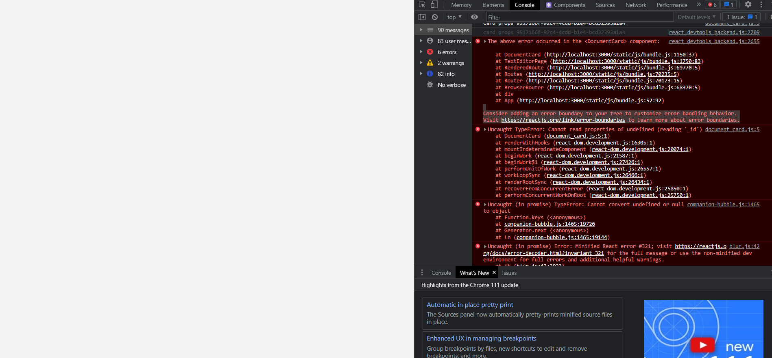

Figure XXX displays a problem where the documents list was not appearing.

The first fix that was attempted was by adding an error boundary to the code.

This can be seen in figure XXX:

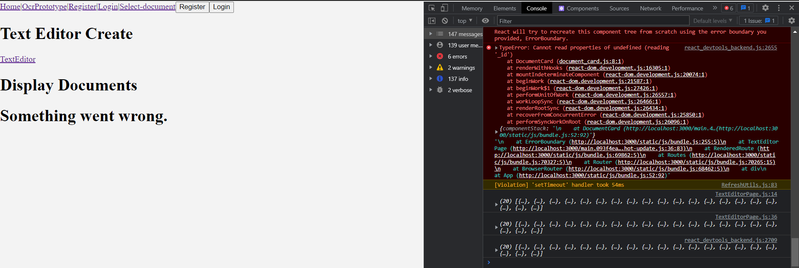

The result of this brought back the pages, however despite this, the problem was still occurring. This was fixed by removing document card from the return, and instead putting “documentList” in between the error boundary. This can be seen in the figure below:

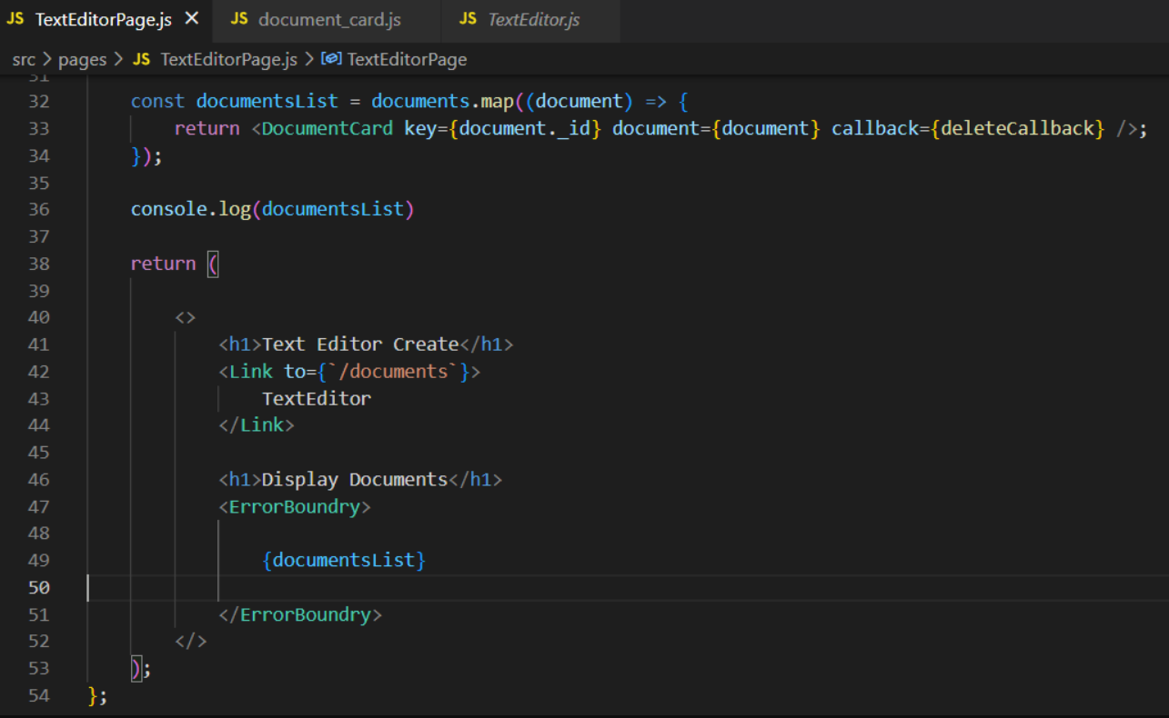

And the result can be seen in figure XXX:

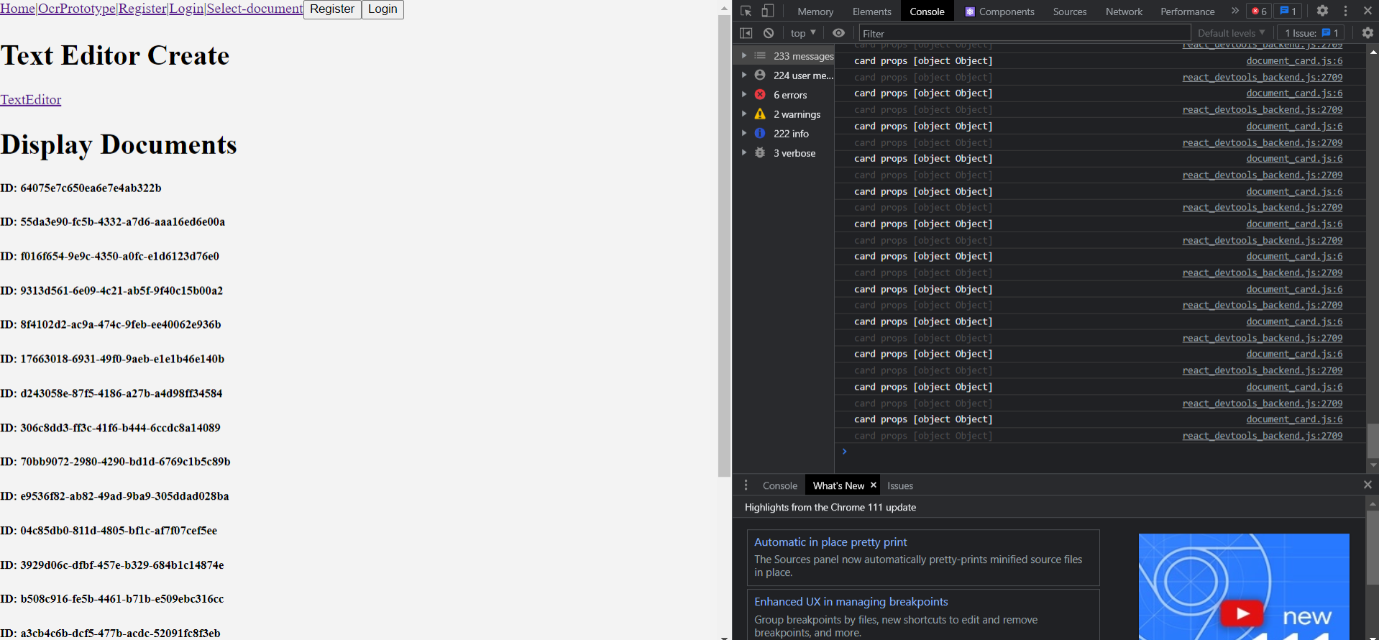

The problem was solved, and the document id was being displayed for all documents.

**Problem 2:**

The next problem that occurred was during the development of the image upload feature. The error can be seen in figure XXX:

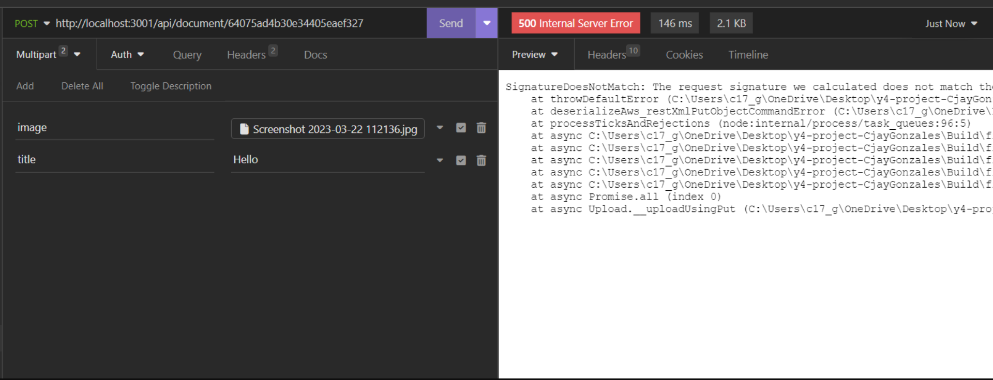

This was occurring because aws-sdk/client-s3 was not installed on the system, and was fixed by an “npm install” command, as seen in figure XXX:



**Problem 3:**

Problem 3 took slightly longer to fix. A Multer error was occurring, and did not let me upload my images, the error can be seen in figure XXX:

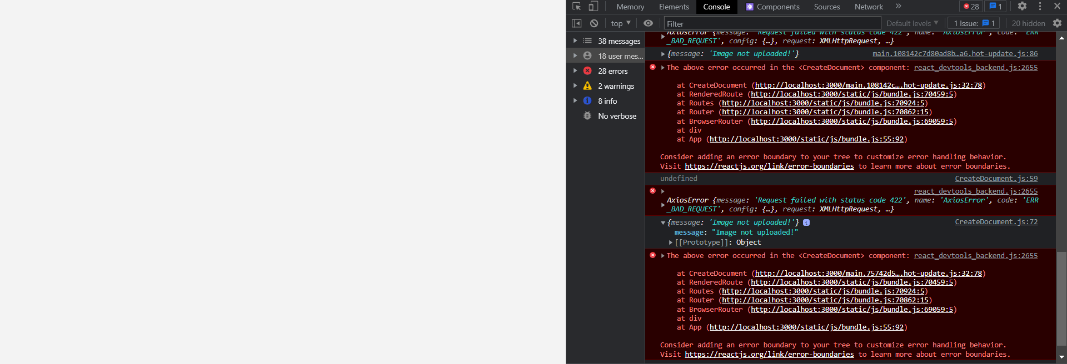

The problem was that the form didn’t allow for images to be uploaded, and the frontend needed to be altered to accept a multiform data.

The handle image function was added to allow images to be uploaded seen in figure XXX:

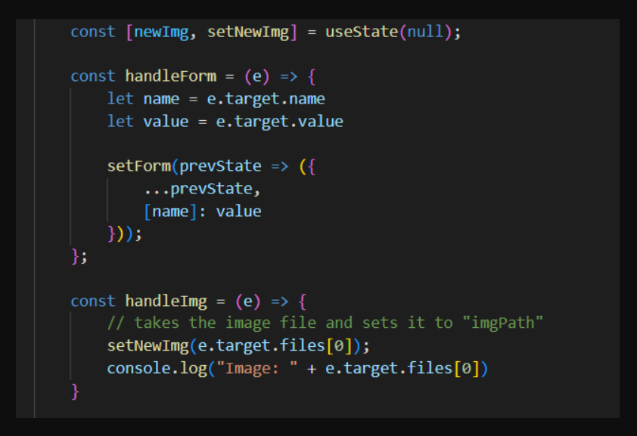

Figure XXX shows sets the image to newImage

Once this was completed another error occurred, preventing the image upload. This was fixed by changing “imgPath” to “image” in the form.append line in the figure below:

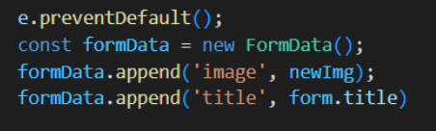

Once this was completed, the image upload feature was fully functional, and the user can successfully upload images alongside the document.

## Sprint 6 – Testing

### Goal

Intro paragraph

* **Item 1:** Further developing the folder structure, adding document folders to application.
* **Item 2:** Updating Navbar to an MUI Navbar component.
* **Item 3:** Styling Frontend and pages.
* **Item 4:** Adding Backend for OCR Reader, saving images and results.
* **Item 5:** Adding image upload for folders.
* **Item 6:** Added CRUD Functionalities for the folders, and OCR Reader.
* **Item 7:** Bug Fixes and Problems

## Sprint 7 – Thesis

**[INCLUDE IMAGES OF FINISHED PRODUCT]**

## Conclusion

Write a couple of paragraphs summing up the chapter. Explain what area your project is about. Describe what the chapter has discussed.

# Testing

## Introduction

This chapter describes the testing that has been undertaken for the application. This chapter is presented in two sections:

1. Functional Testing
2. User Testing

Functional testing is a type of software testing whereby the system is tested against the functional requirements. The app is tested by looking to see if the actual output for a given input corresponds with the expected output. The tests should be based on the requirements for the app. The results of functional testing can indicate if a piece of software is functional and working, but not if the software is easy to use.

User testing looks to see if a piece of software is easy and intuitive for the user.

## Functional Testing

This section describes the functional tests which were carried out on the app. These functional tests can be categorised as: (whatever is relevant to your app)

* Navigation
* Calculation
* CRUD

Functional testing generally uses a Black Box Testing technique which means that the internal logic of the system being tested is not of interest to the tester. The tester is only interested in whether the actual output agrees with the expected output.

### Navigation

|  |  |  |  |  |  |
| --- | --- | --- | --- | --- | --- |
| Test No | Description of test case | Input | Expected Output | Actual Output | Comment |
|  |  |  |  |  |  |
|  |  |  |  |  |  |
|  |  |  |  |  |  |

### Calculation

|  |  |  |  |  |  |
| --- | --- | --- | --- | --- | --- |
| Test No | Description of test case | Input | Expected Output | Actual Output | Comment |
|  |  |  |  |  |  |
|  |  |  |  |  |  |
|  |  |  |  |  |  |

### CRUD

|  |  |  |  |  |  |
| --- | --- | --- | --- | --- | --- |
| Test No | Description of test case | Input | Expected Output | Actual Output | Comment |
|  |  |  |  |  |  |
|  |  |  |  |  |  |
|  |  |  |  |  |  |

### Discussion of Functional Testing Results

## User Testing

Use the report which you have written for Interaction Design.

## Conclusion

Write a couple of paragraphs summing up the chapter. Explain what area your project is about. Describe what the chapter has discussed.

# Project Management

## Introduction

This chapter describes how the project was managed and how well the group worked together as a team. It shows the phases of the project, going from the project idea through the requirements gathering, the specification for the project, the design, implementation and testing phases for the project. It also discusses Trello, GitHub and project member’s journals as tools which assist in project management.

## Project Phases

In this section, describe each of the following project phases. Explain any issues which arose for each of the phases.

### Proposal

### Requirements

### Design

### Implementation

### Testing

## Team Work

### Roles

### Communication

### Difficulties

### Resolving Difficulties

## SCRUM Methodology

Look at Project Guidelines

Sprints

How well did the 7 sprints work?

Requirements

Project Backlog

## Project Management Tools

### Trello

Description

Include diagrams

How it worked in practice

### GitHub

Description

How it is used

How it worked in practice

### Journal

Description

How it was used

How useful it was in practice

## Reflection

### Your views on the project

Describe how you feel the project went from your perspective and from the team’s perspective.

### Completing a large software development project

Describe what you have learnt from the project, from the point of view of completing a large software development project.

### Working in a team

Describe what you have learnt from the project, from the point of view of working in a team.

### Working with a supervisor

Describe how you feel the project went from the point of view of working with a supervisor.

### Technical skills

Describe what you have learnt from the project, from a technical skills viewpoint.

### Further competencies and skills

Describe any extra competencies and skills that would help you with your development in the work place.

## Conclusion

Write a couple of paragraphs summing up the chapter. Explain what area your project is about. Describe what the chapter has discussed.

# Business Opportunities

This is from your module with Tim McNicholls

# Conclusion

One paragraph on the background, the overall aim and the goals of the project.

One paragraph on the technologies used in the project.

Research

Design

Implementation

Testing

Overall result

Project management

What was learnt

How the project could be further developed

# References

David, H. (2022, 6 27). *Hubspot*. Retrieved from What is React.js? (Uses, Examples, & More): https://blog.hubspot.com/website/react-js#:~:text=The%20React.,you%20would%20with%20vanilla%20JavaScript.

*Express - Node.js web application framework*. (2017). Retrieved from Expressjs.com: https://expressjs.com/

Ferguson, K. (2021). *Application architecture*. Retrieved from TechTarget: application architecture

Karnik, N. (2018, 2 11). *Introduction to Mongoose for MongoDB*. Retrieved from freeCodeCamp.org: https://www.freecodecamp.org/news/introduction-to-mongoose-for-mongodb-d2a7aa593c57/

Node.js. (2023). *About | Node.js*. Retrieved from Node.js: https://nodejs.org/en/about/

*What Is MongoDB?* (2022). Retrieved from MongoDB: https://www.mongodb.com/what-is-mongodb